J-Link Edu ITM Trace (printf) Guide

1. Add my custom created debug.h and debug.c files to the project. Include debug.h to any file in the project that would be calling printf statement
2. Jlink Edu Trace Settings
   1. Go to Target Options > Debug Tab. Select “Use Jlink / JTrace” and click on Settings.
   2. In the Debug window Select ‘use SW’ and speed 10Mhz  
      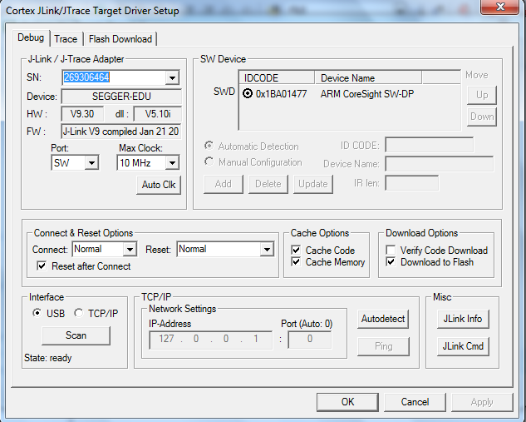
   3. Go to the Trace Window
      1. Enable Trace
      2. Set the Core Clock = SYSCLK frequency
      3. Under Trace Port select Serial Wire Output
      4. Check ‘Autodetect Max SWO Clk’
      5. Under PC Sampling, check ‘on Data R/W Sample’
      6. Under ITM Stimulus Ports uncheck all and check ITM PORT 0 (Used for printf)  
         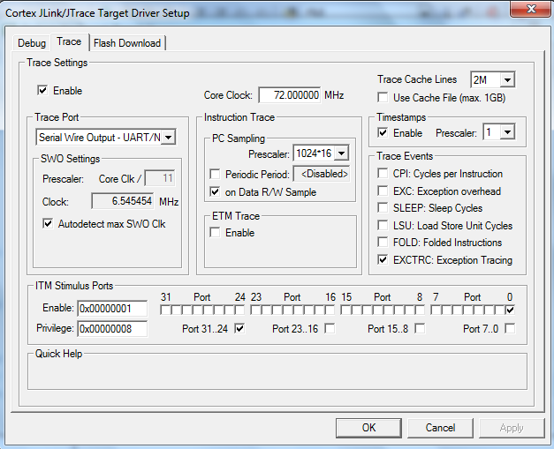

To View The Trace Output Data

1. In the main program window, click on Start /Stop Debug Session to upload the code to the mcu and start the debug session
2. In Debug window, open the Printf-Viewer window by going to View -> Serial Windows -> Debuig(Printf) Viewer
3. To Run/Execute code in Real Time and see the debug/printf output, Click on Run or hit F5

References:

1. <http://www.keil.com/support/man/docs/jlink/jlink_cortextrace.htm>
2. <http://www.keil.com/support/man/docs/jlink/jlink_trace_itm_viewer.htm>
3. <http://blog.siliconlabs.com/t5/32-bit-MCU/SWO-printf-in-Keil/td-p/98107>